IBM Watson IoT platform

**Project Title**: Smart Solution for Railways **Team ID**: PNT2022TMID42986

Step 1: Open IBM cloud and go to catalog

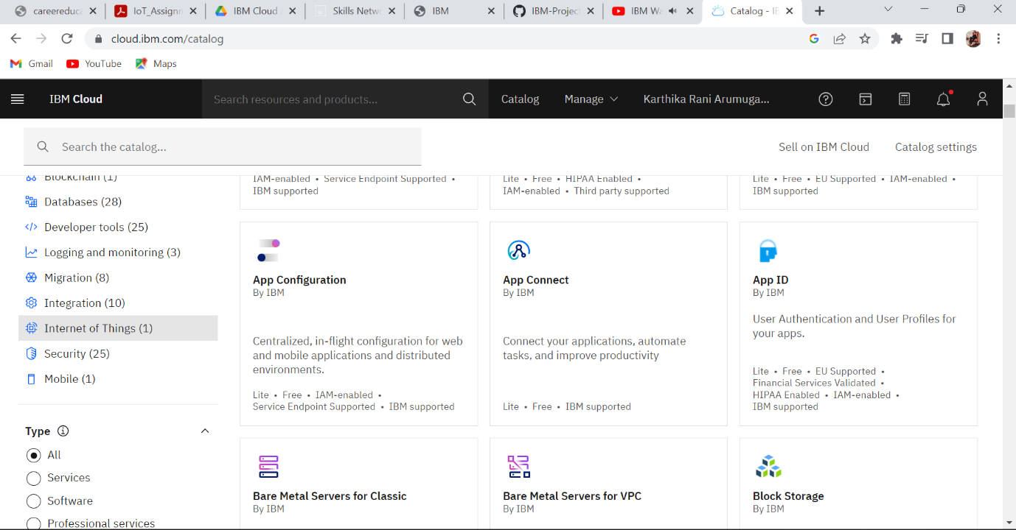



Step 2: Go to Internet of things and click it

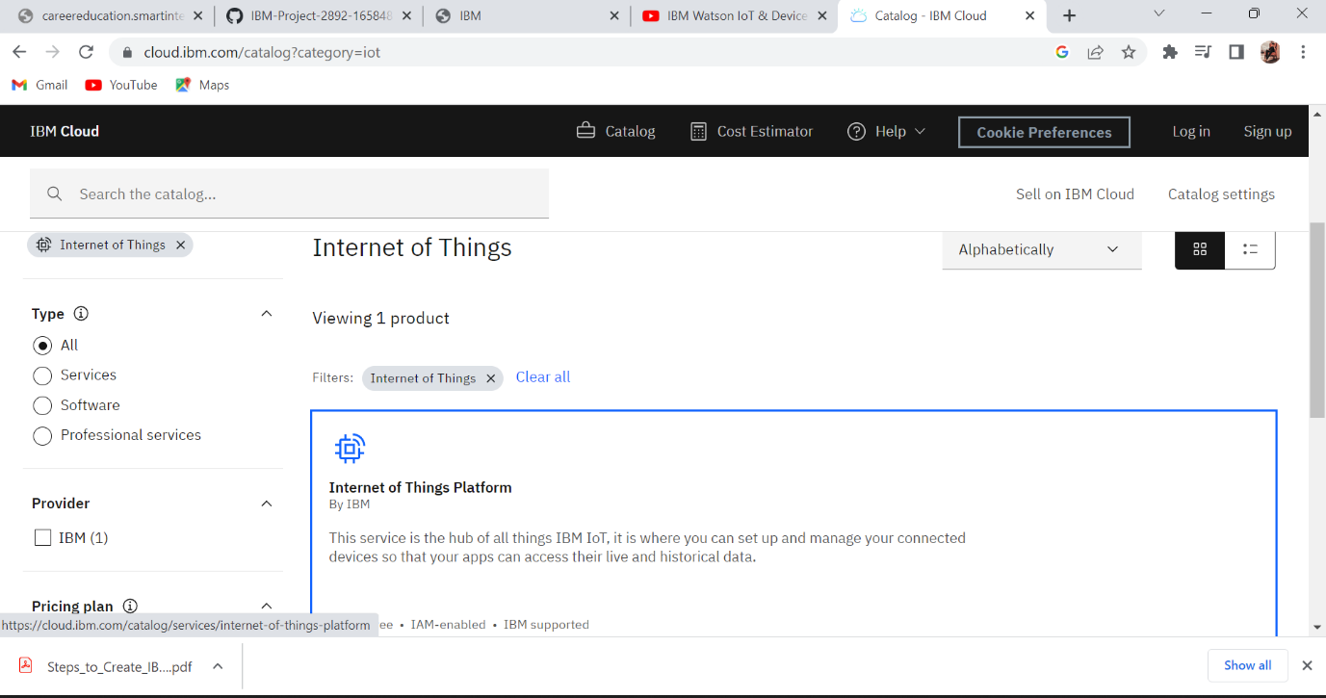

Step 3: Click launch for create new device

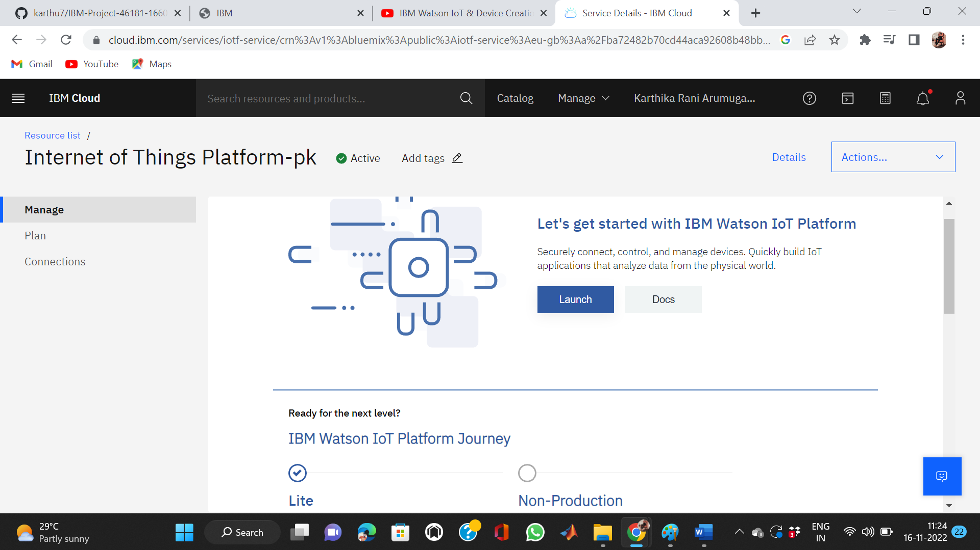

Step 4: After sign in IBMid the window will show like below

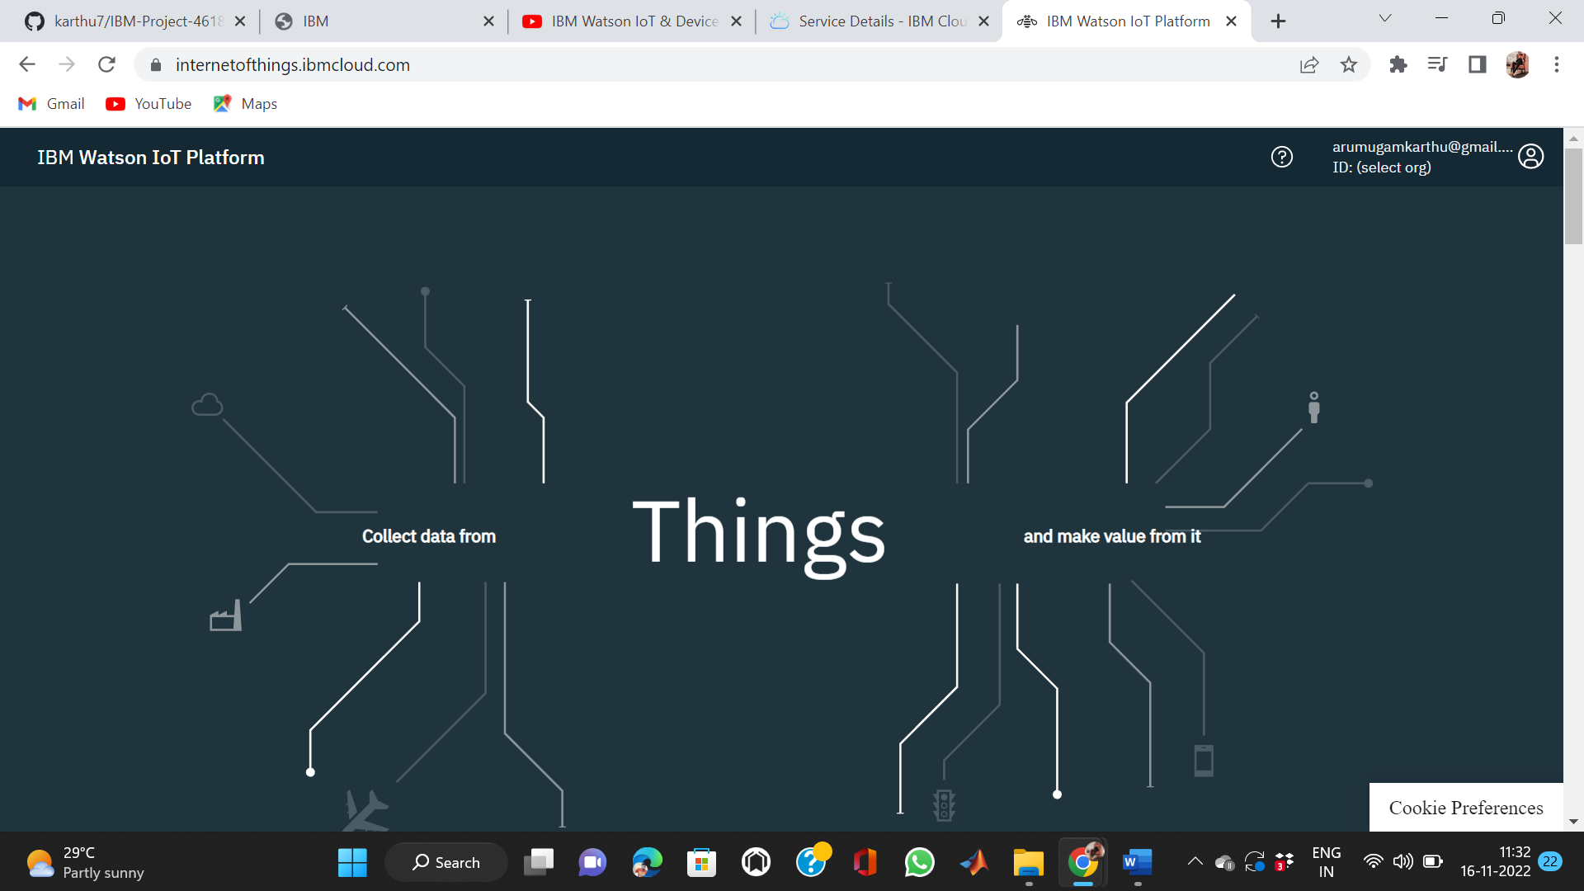

Step 5: After creating device click finish to show the device on IBM Watson IoT

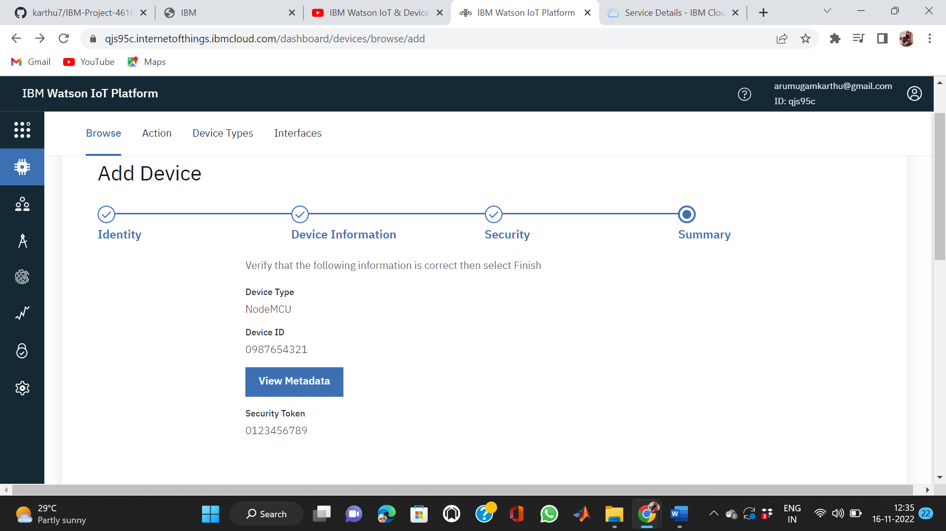

Step 6: Copy the device credentials

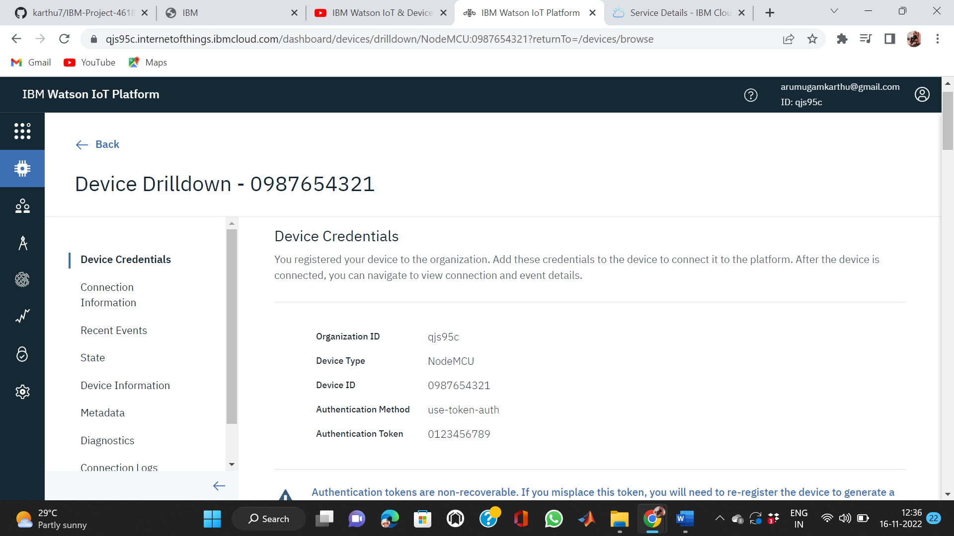

Step 7: Finally Watson IoT shown below and it done

